|  |
| --- |
| **SmartAttend_V1.0** |
|  |



**Cloud Computing Project Final Report**

Team Members, Class ID:

Chakra Pavan Kumar Kota,

Dharani Muli.

**1. TITLE:** SmartAttend

# **Motivation**

By observing some of the concerns faced by instructors in every class to track the attendance we were motivated to provide a solution to eradicate the issue.

# **3. Objective**

To bring ease in tracking the attendance for instructors.

**Systems Features:**

* + 1. **For Instructor** 
       1. Login
       2. Generate QR code
       3. Attendance Report
       4. Detailed Report
    2. **For Student:**
       1. Login
       2. Take Attendance
       3. Attendance report
    3. **Other:**
       1. Deployed into play store

# **4. Tools, languages and platforms**

1. Ionic 4
2. Html5, CSS3
3. Angular 7
4. Mongo DB
5. Expressjs
6. Node.js
7. Heroku
8. Android SDK
9. X-Code
10. WebStorm
11. Github
12. App Store
13. Google paly store

# **5. Type of project:** Development (Mobile application)

**6. Block Dragram:**

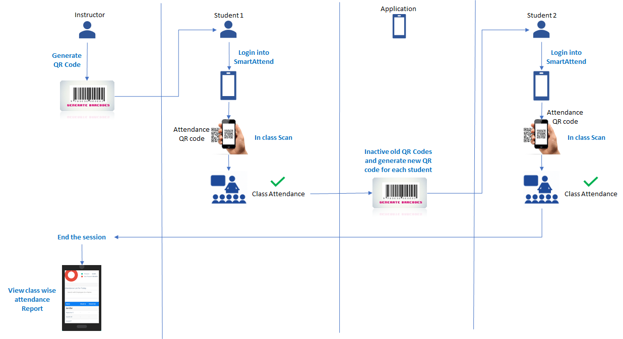

**7. Role of team members:**

* Research – Pavan (owner), Dharani
* Documentation – Pavan, Dharani (owner)
* Development – Pavan (owner), Dharani
* Project Management – Pavan, Dharani (owner)
* Performance Evaluation: Pavan, Dharani (owner)

**8. System architecture:**

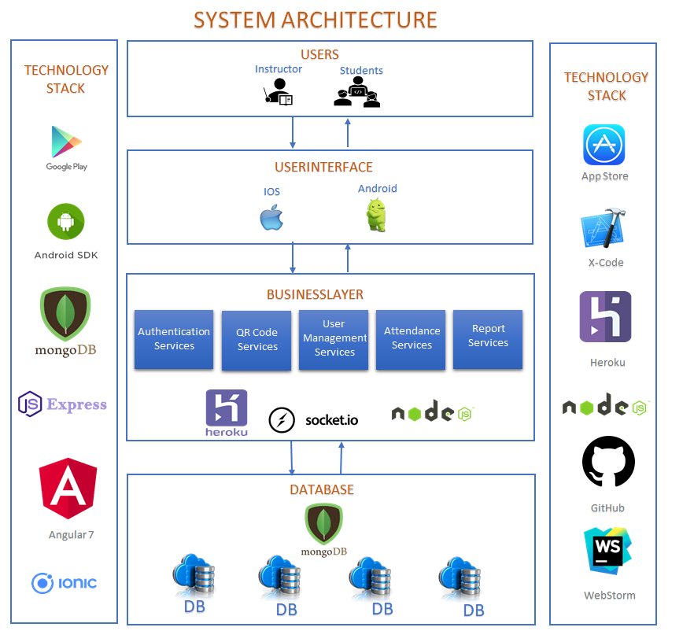

**9. Product journey**

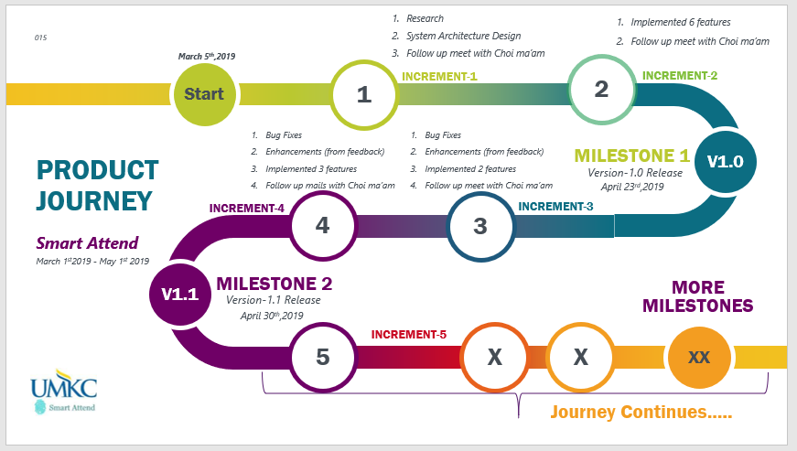

**10. Future Features:**

* 1. App store deployment
  2. Securable application
  3. User should request instructor to add attendance if they user is unable to take the attendance. Ex: if student don’t have phone
  4. Build Statistics
  5. Late Attendance tracker
  6. Course wise attendance
  7. Enhancements in Reports
  8. Make Robust
  9. Web based application for Instructor
  10. Instructor profile management
  11. Student Profile management

**11. Screenshots of Version_1.0**

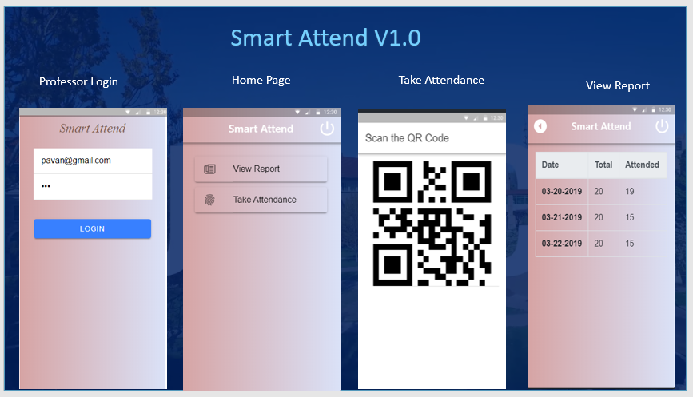

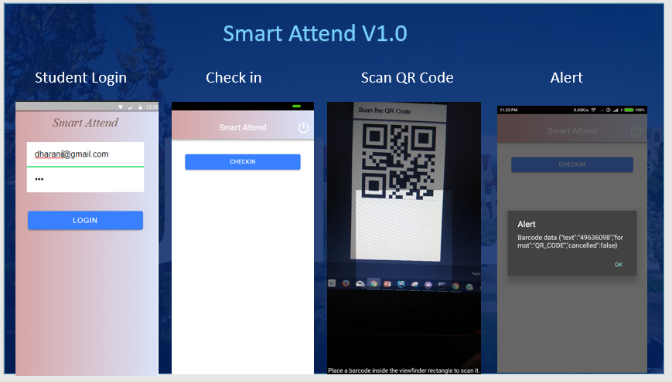

* 1. **ScreenShots of Version_1.1**

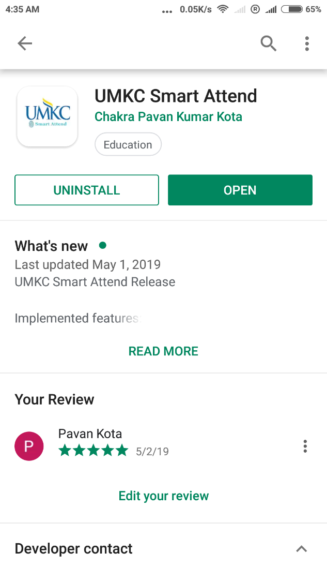

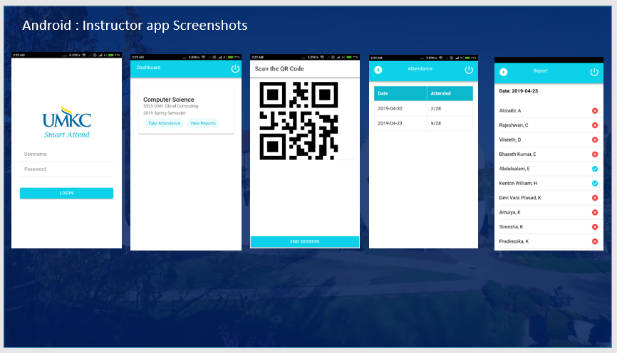

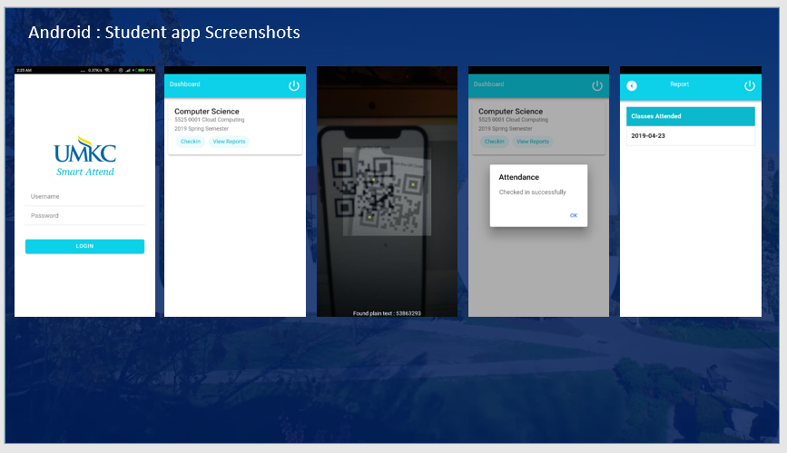

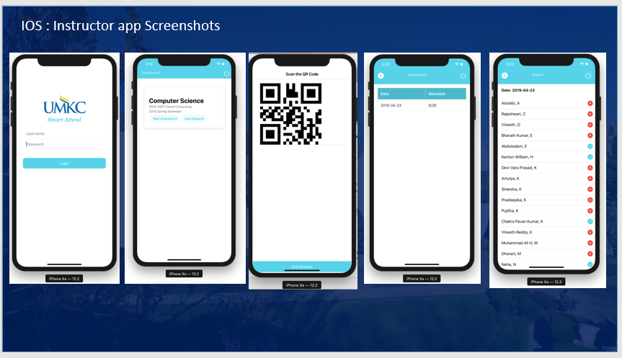

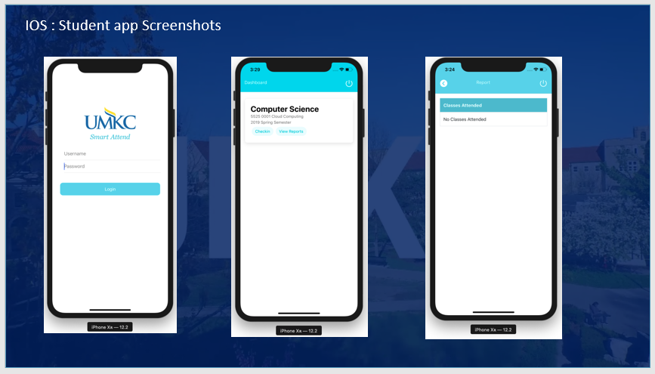

**13. Expected project poutcome**

1. Build a real time attendance app
2. Easy to use
3. Support IOS and Android

**14. challenges and findings**

1. **Problem** : New QR code generation after every check in.

**Solution** : Socket implementation

2. **Problem** : Deployment is needed for every change in backend

**Solution** : Implemented CICD using GitHub and Heroku.

3. **Problem** : Digitally signing apk is a cumbersome process

**Solution** : Hunted through google documentation.

**15. Individual learning outcome**

Chakra Pavan Kumar, Kota:

1. By end of the project I had hands-on experience on mentioned software tools.
2. Explored the functionalities of cloud services.
3. Developed and published IOS and Android app.
4. Worked and collaborated in an efficient way with team.

Dharani, Muli:

1. By end of the project I had hands-on experience on mentioned software tools.
2. Also gained knowledge of the best coding standards.
3. Developed and published IOS and Android app.
4. Improved collaboration skills working in a team.

**Our GitHub Repository**

Front End:

<https://github.com/pavankotas/SmartAttend>

Back End:

<https://github.com/pavankotas/SmartAttendBackend>

Wiki Link

<https://github.com/pavankotas/SmartAttend/wiki>